**SetUp and Creation of Repository in GitHub**

* Initially we need to create and account in GitHub. Please follow the link for account creation in github [*https://github.com/join*](https://github.com/join)

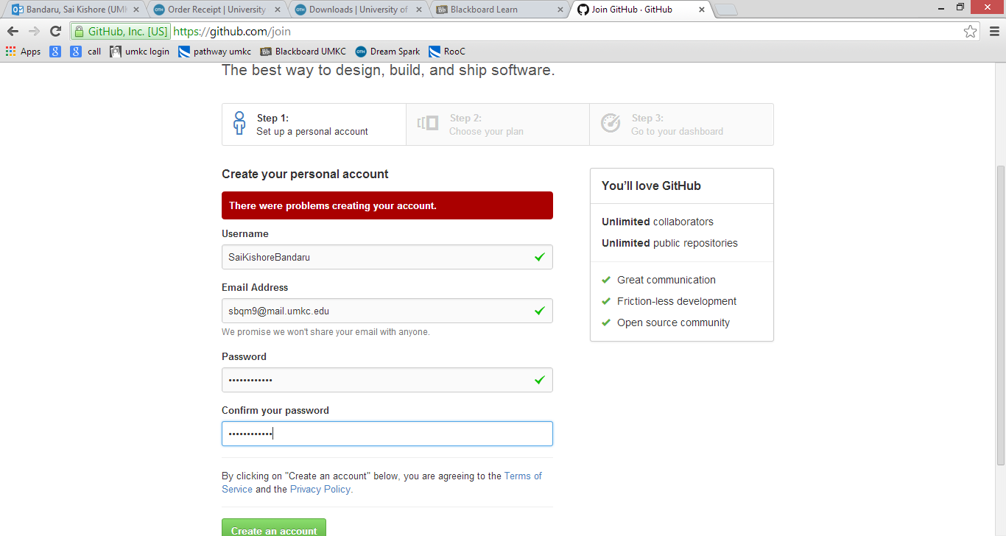

Figure GitHub account creation

* Choose free subscription and proceed further .

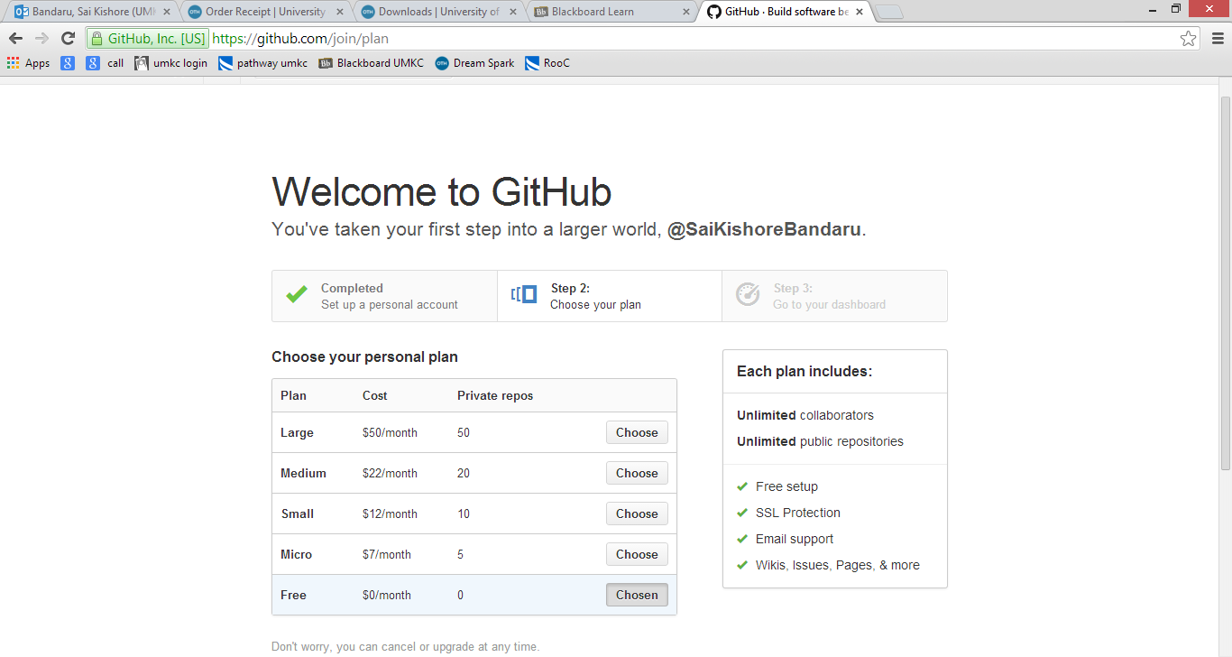

Figure Plan Option

* After completion of the account creation , we need to create a new repository in order to check in the projects.
* In the home page please select Create Repositories.

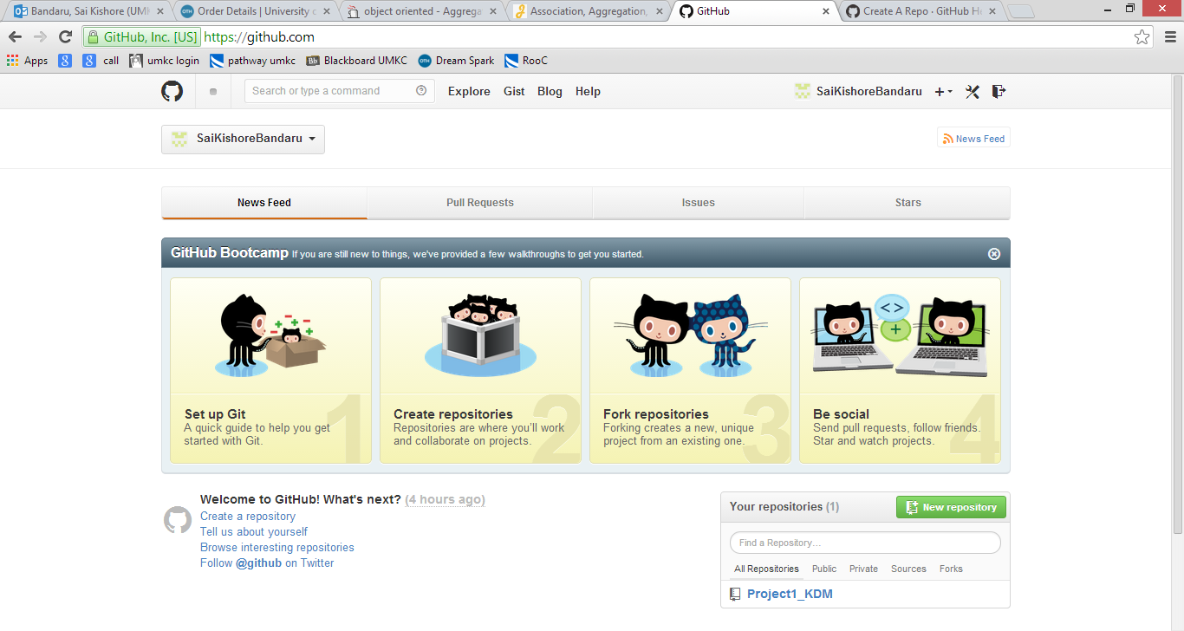

Figure Select create repositories

* After selecting create repositories , we will be navigated to a new tab and here we need to select Click New Repository.

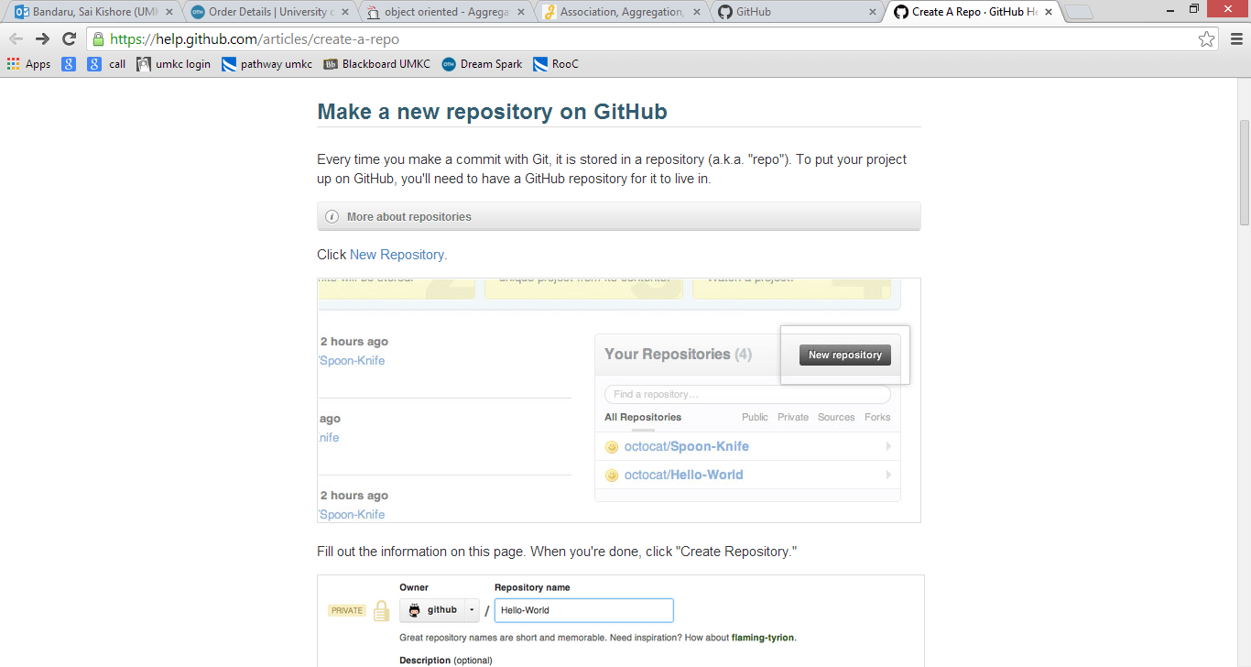

Figure Creating new repository

* Enter the repository name and description and make it available to public if needed or check the private check box if the repository has to be maintained secured and then click Create Repository.

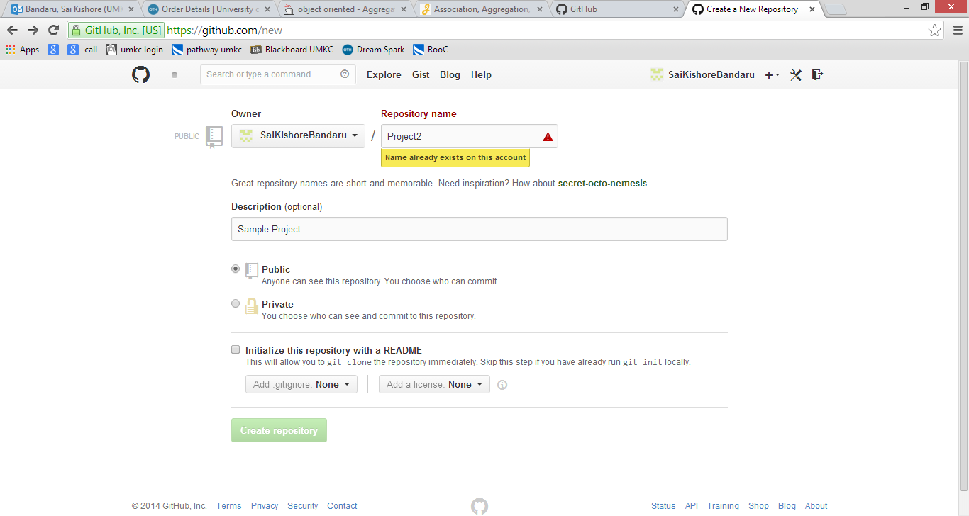

Figure Project Creation

* After creating the repository you will be provided with a link and an option set the repository to desktop. Please click “SetUp In Desktop”
* If GitHub is not installed on your machine, it prompts to install it.
* After installing GitHub Windows, please open the GitHub App.
* Now on the home page under your account the created repositories will be displayed.
* In order to clone the repository on to your desktop please click clone on the project

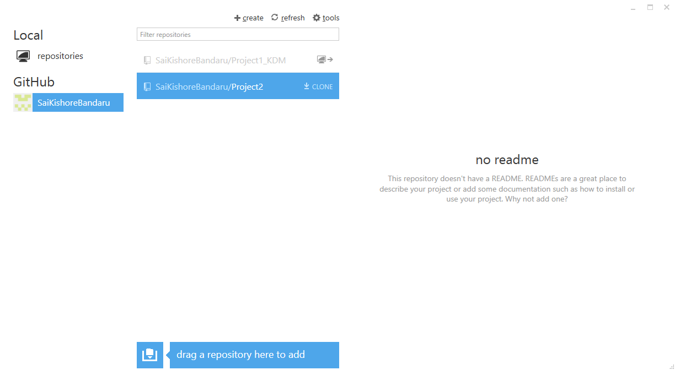

Figure Cloning the repository

* The default location of the cloned repository would be “C:/Documents/UserName/Documents/GitHub”
* Now to check in a document into a repository, open the github application and double on the repository to which you want to check in.
* Now a window will be displayed with the uncommitted changes and mark those uncommitted files and enter the summary,description and click “Commit To Master”

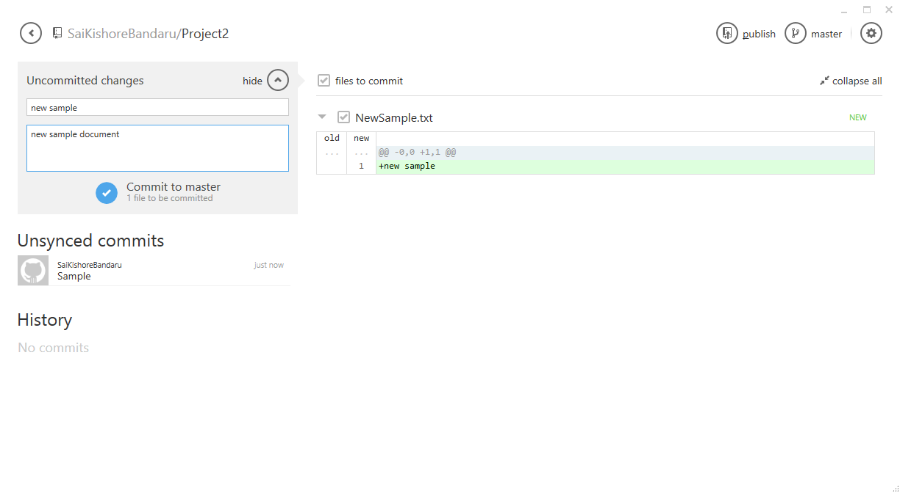

Figure Committing the changes

* After committing the changes sync the changes to repository.

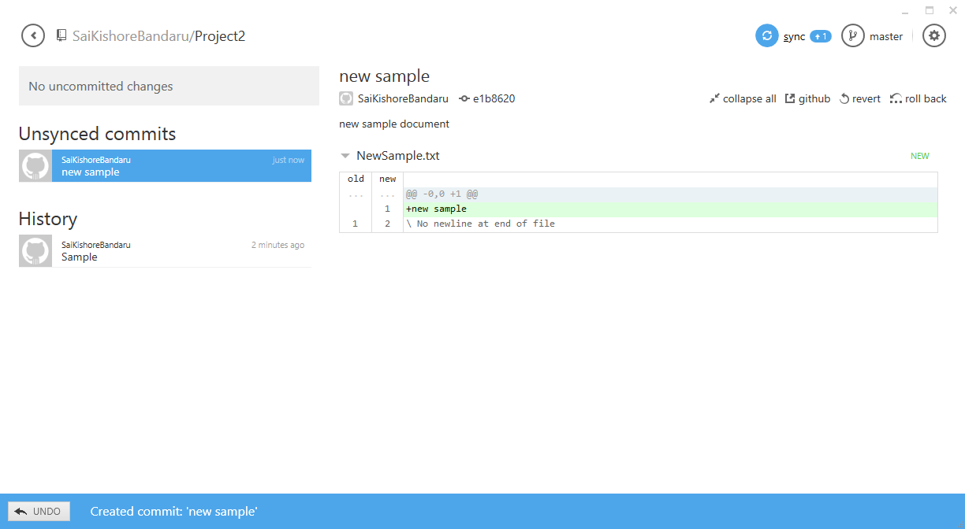

Figure Sync changes to Repository by clicking sync